**Docker Workflow**

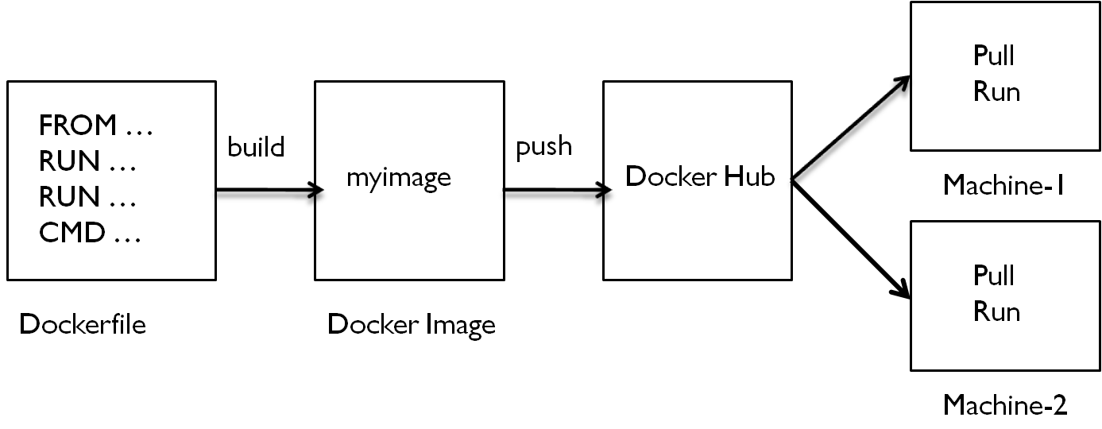

**Etl.py**

import streamlit as st

import pandas as pd

data = {

        'Task': ['Extract', 'Transform', 'Load'],

        'Status': ['Completed', 'InProgress', 'Pending']

    }

df = pd.DataFrame(data)

st.write('ETL Pipeline Execution Status', df)

**Dockerfile**

FROM python:3.9.19-slim

RUN pip install streamlit

WORKDIR /var

COPY . .

EXPOSE 8501

# Run streamlit application

CMD ["streamlit", "run", "etl.py"]

**Create docker image**

docker build -t myimage .

**Tag Docker Image**

docker tag myimage username/myimage

**docker hub Login**

docker login

**Push Image to docker hub**

docker push username/myimage

**Pull Image from docker hub**

docker pull username/myimage

**Create Container**

docker run –name=mycontainer -d -p 8501:8501 myimage